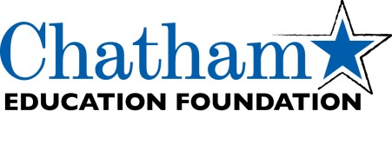

GRANT APPLICATION DUE DATES AND REVIEW DATES
2021-2022
This year, the Chatham Education Foundation is accepting grant applications from Teachers and Staff, Building Principals, Supervisors and the District from September through May.
- The Assistant Superintendent of Curriculum and Instruction and the CEF Board of Trustees reviews completed applications that have been received.
- Applicants will be notified following the next CEF Board meeting if their grant application was accepted or denied.
- Grants must be approved by the Board of Education following approval by the CEF Board. Funds typically are released for grants upon BOE approval.
- Grant applications received after May 15 will be reviewed the following school year.
Prior to completing a grant application, please review our “Funding Guidelines and Grant Procedures” under the Grants Tab on our website (www.chathamedfoundation.org).
CEF strives to fund as many quality applications as possible each year but operates on the financial generosity of the community and a limited funding budget. CEF welcomes inquiries to discuss viability of grant applications and projects. Please contact the Grants Committee at cefgrantscommittee@chathamedfoundation.org or Cheryl Whitney at cheryl.whitney@chathamedfoundation.org with any questions.
APPLICATION TIMELINE
APPLICATION DEADLINE | CEF VOTE | BOE APPROVAL DATE
September 15 | October 5 | October 11
October 15 | November 2 | November 15
January 15 | February 1 | February 7
April 15 | May 3 | May 16
May 15 | June 7 | June 20

Updated July 13, 2021

